***My Top 10 Books and 10 Podcasts for 2023***

By: Almetrice Shavers

I have always loved to read. I have tried to get back in the habit of reading more and use it as a part of my self-care. I started listening to Podcasts in 2020. Where have they been all of my life? I’m not sure when Podcasts even started becoming popular, I’m late as usual. With my job I'm traveling all the time around Arkansas, so these Podcasts have become my favorite to listen to. You can gain so much knowledge from Podcasts. Just about any topic you want to listen to is available. I have subscribed and keep certain Podcasts in rotation every week. In this season of my life, I try to be cautious of what I listen to and allow into my mental space. I’m going to list my top 10 Podcasts. No particular order, these are just my favorite ones.

1. The Table w/ Anthony ONeal (Finances, wealth, entrepreneurship, and culture)
2. Black, Married & Debt Free (Finances,culture, marriage and family)
3. Dear Future Wifey (Marriage, relationships, spiritual, healing, culture and family)
4. Fridays with Tab & Chance (Marriage, family, relationships, culture, health and spiritual)
5. Balanced Black Girl (Personal self growth and health)
6. The His & Her Money Show (Finances, marriage, spiritual and family)
7. Dead Ass with Khadeen & Devale (Marriage, relationships, parenting, culture, family, health, etc.)
8. Woman Evolve (Spiritual, self growth and culture)
9. Know For Sure (Personal self growth and culture)
10. Keep It Positive Sweetie (Personal self growth)

Here are 3 podcasts for my spirituality and when I need a good word from the Lord.

1. The Basement with Tim Ross
2. Transformation Church
3. Jerry Flowers

These podcasts have been literally life changing for me. They have hit every area of my life as far as self-care, relationships, marriage, parenting, finances, health, emotional, spiritual, personal growth and the list goes on. Since I listen to these podcasts weekly, I've noticed over the last couple of years I don’t watch as much television anymore. Even while I work from home, I'll turn my speaker on and listen to them all day. All of these have new episodes every week, so I'm never bored. The days I travel far for work, I definitely make sure to save a few episodes to have while driving. It helps the time go by faster. These podcasts have been life changing and the insight I have gotten over the years has been phenomenal. No matter what season I'm in in life they are always relevant. I include these podcasts as part of my therapy and self-care.

So here is a list of my favorite books I have read in 2023. These 10 books are amazing and definitely a part of self development and growth. After I read each book, it caused some mind shifting. I had to change the way I thought about things, what I said and even how I reacted to things. I love to actually hold a book in my hand and read it. I love learning new things and receiving wisdom. I read books because of the knowledge I obtain. I believe you will continue learning for the rest of your life. These books have helped me show up for myself differently.

1. The Power of a Praying Parent- Stormie Omartian (Faith Based)
2. Rich Dad Poor Dad- Robert T. Kyosaki (Finances)
3. The Gifts of Imperfection- Brene`Brown (Self-Development)
4. The Four Agreements- Don Miguel Ruiz (Self-Development)
5. Feeding The Soul- Tabitha Brown (Self-Development)
6. Girl, Wash Your Face- Rachel Hollis (Faith Based)
7. Crazy Faith- Michael Todd (Faith Based)
8. The Secret to Success- Eric Thomas (Self-Development)
9. The Power of Praying Through Fear- Stormie Omartian (Faith Based)
10. Battlefield of the Mind- Joyce Meyer (Faith Based)

Look below

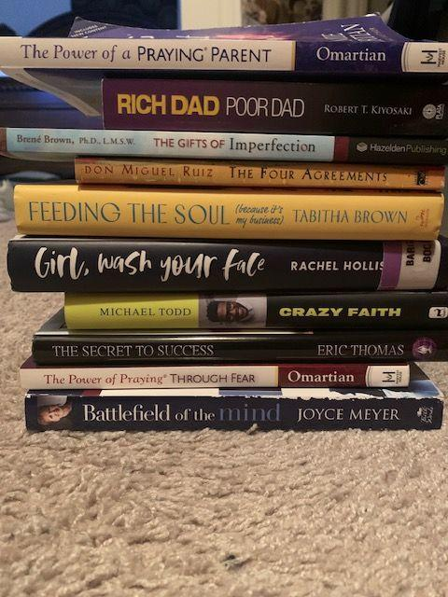

I hope these books and podcasts really bless your life and help in your personal growth in some form. Be on the lookout at the end of 2024 for my new lists of books and podcasts. I love you all and until next time just know you deserve God’s peace and love!